Information Technology

Software development

For

Business 2

Tutor name: Phil Campbel

Groups A

Author:

Raitis Kupce (3124749)

16th May, 2013

Informatics Department

London South Bank University

**Contents**

|  |  |  |  |
| --- | --- | --- | --- |
| **Description** | **Complete** | **Code**  **Page no** | **Evidence**  **Page No** |
| I can open a file, read in the lines and split the lines into fields. | ✓ | 3 | 3 |
| I can get the program to calculate the answers to (some of) my questions. | ✓ | 3-4 | 3-4 |
| I have modified the code to use Classes and Objects | ✓ | 4 | 4 |
| I have developed a GUI to interact with the user | ✓ |  |  |
| I have written my report on the research |  |  |  |
| I have changed the code based on my research | ✓ |  |  |
| I have written an evaluation of what I did |  |  |  |
| I have tested the classes in my program |  |  |  |

**Code annotated.**

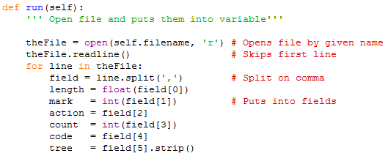I can open a file, read in the lines and split the lines into fields.

I can get the program to calculate the answers to (some of) my questions.

I will use class/object to answer my questions and these are fields that I have used to answer my questions. 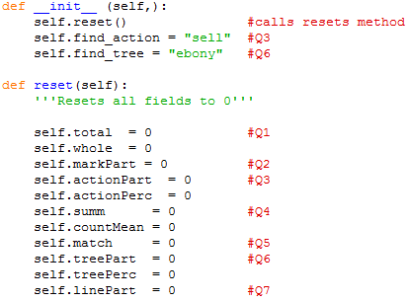Comments refers to the questions.

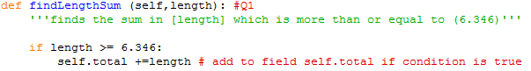Q1. Find the sum of the values in the field [length] more than or equal to ( 6.346).

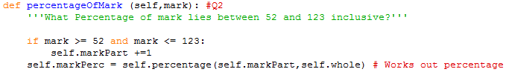Q2. What percentage of the numbers in [mark] lie between (52) and (123) inclusive?

Go to page **10**

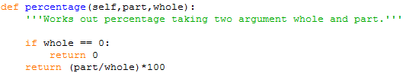

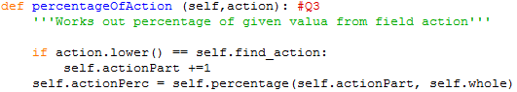Q3. (sell's) are what percentage of the field [action]?

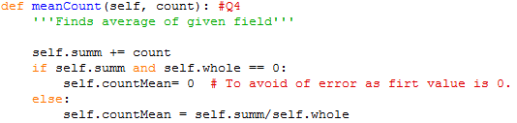Q4. Find the average of the values in the field [count].

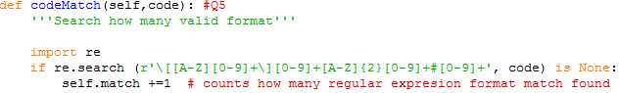Q5. How many values in the 'code' field do not match the format [X9]9XX9#9 ?

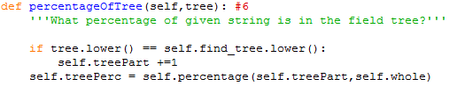Q6. What percentage of strings have the value (Ebony) in the field [tree]?

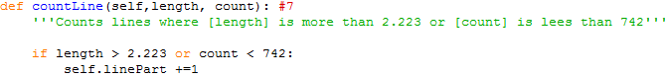Q7. Count the lines where length is more than 2.223 *or* count is less than 742.

I have modified the code to use Classes and Objects.

Reference:

Bibliography:

* Heathrow, 2013, Prayer and Worship. Retrieved *23/04/2013* from: [*http://www.heathrowairport.com/heathrow-airport-guide/services-and-facilities/worship*](http://www.heathrowairport.com/heathrow-airport-guide/services-and-facilities/worship)
* Stackoverflow,2013, Top Questions. Retrieved *23/04/2013* from:[*http://stackoverflow.com/*](http://stackoverflow.com/)